Exploratory Data Analysis for Image Segmentation

Exploratory Data Analytics Report

2/16/2021

Analysis the basic metrics of variables

- Analysis of Basic metrics for Dataset 1(Pets):
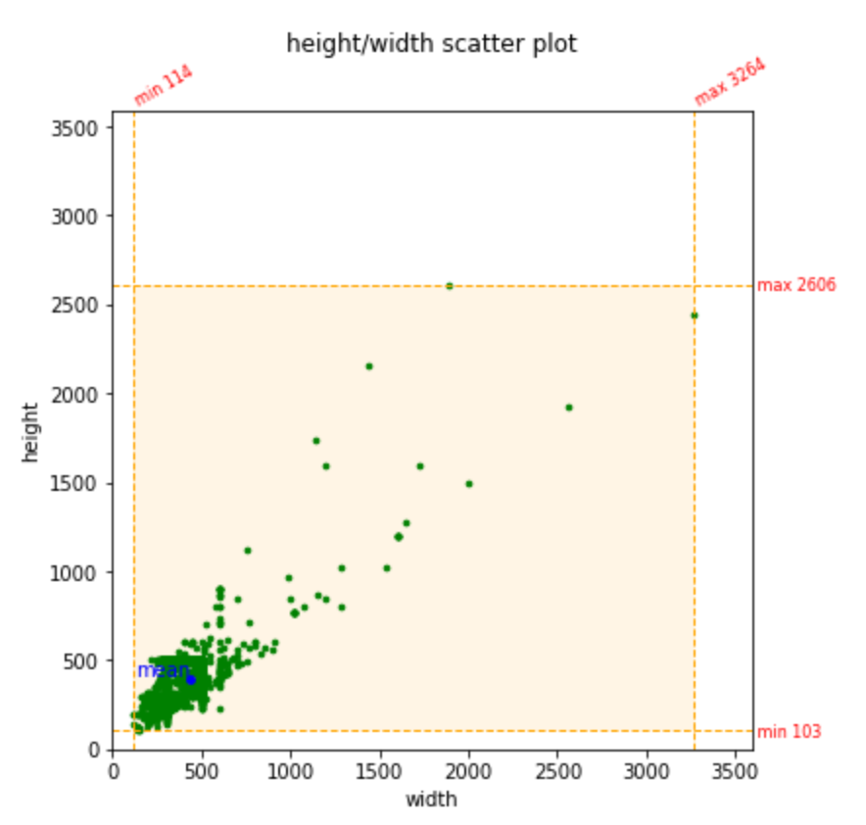
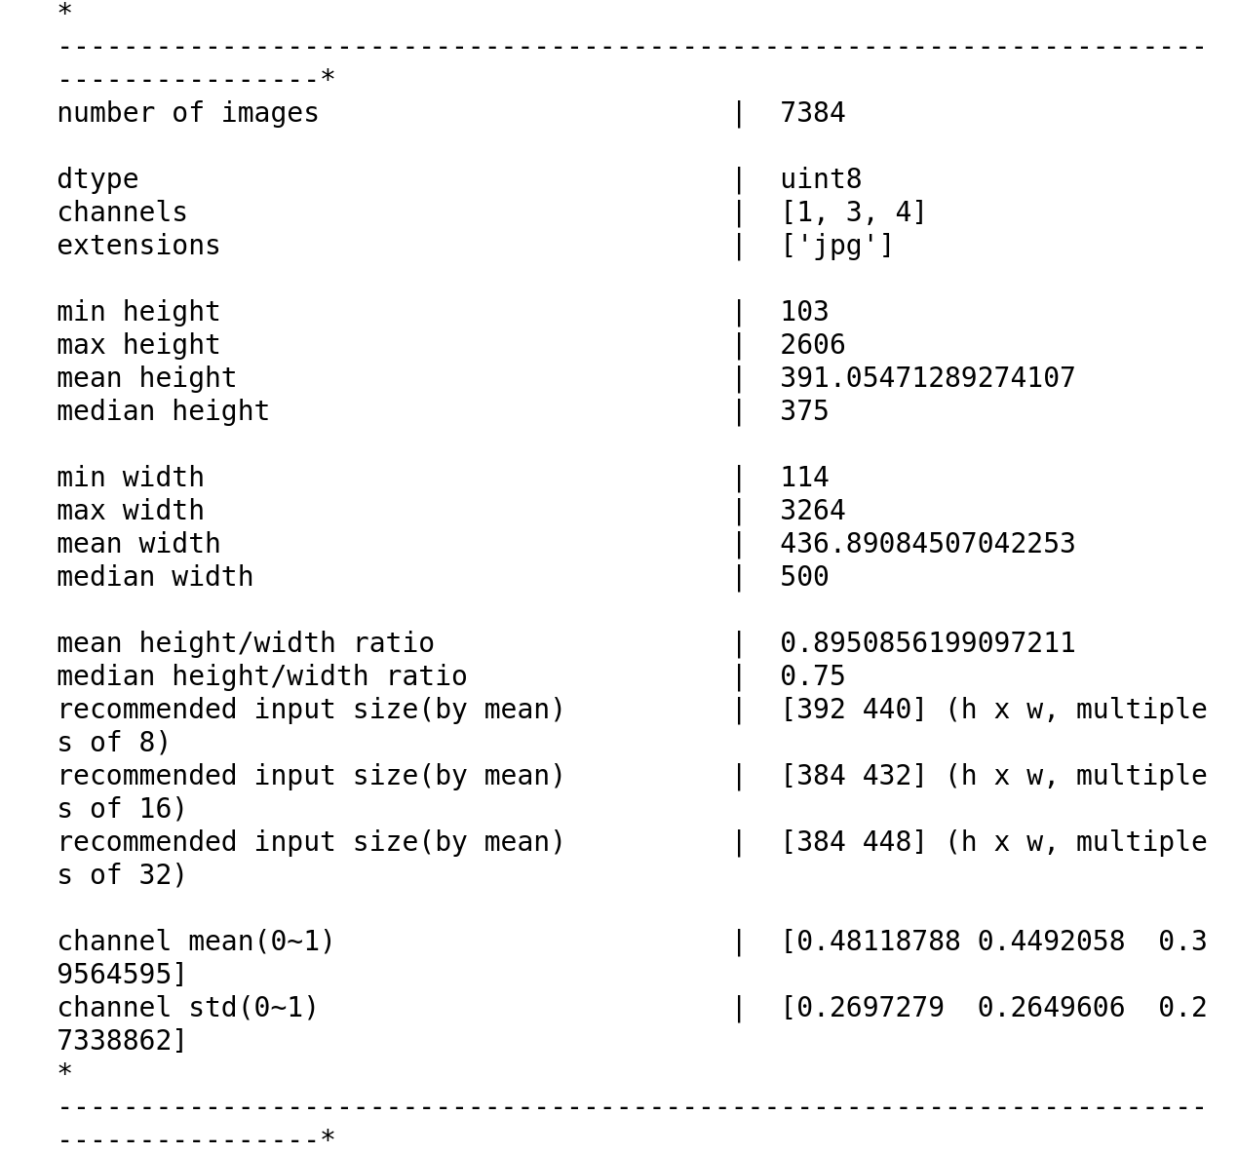
In dataset 1 there are 7,384 images of various breeds of both cats and dogs in multiple poses. The images come in a wide range of widths and height. The pixels in the original image dataset are values in the range from 0 to 255. The dataset also contains the ground truth masking for each of these images. The values for a given pixel for the ground truth mask can be either one, two, or three. Below shows the dtype, how many channels in each image, and basic statistics for image size and pixel values. It shows below that the blue channel has the highest standard deviation of any channel.
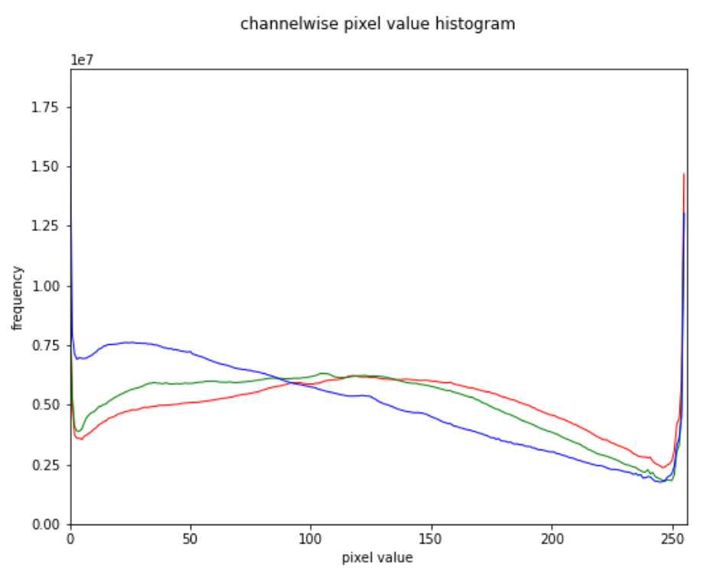
- Analysis of Basic metrics for Dataset 2 (Drone):
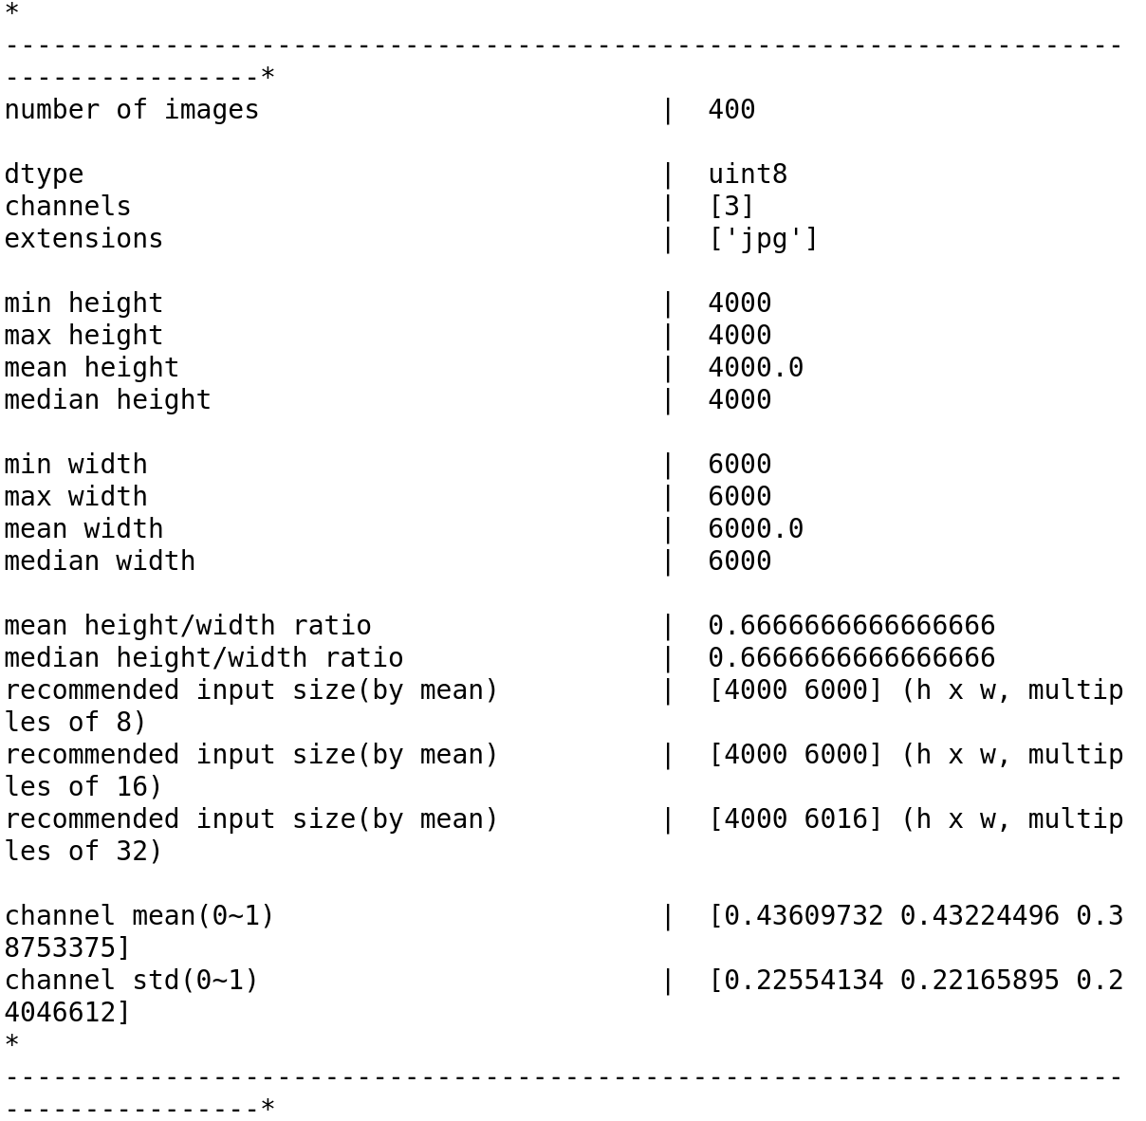
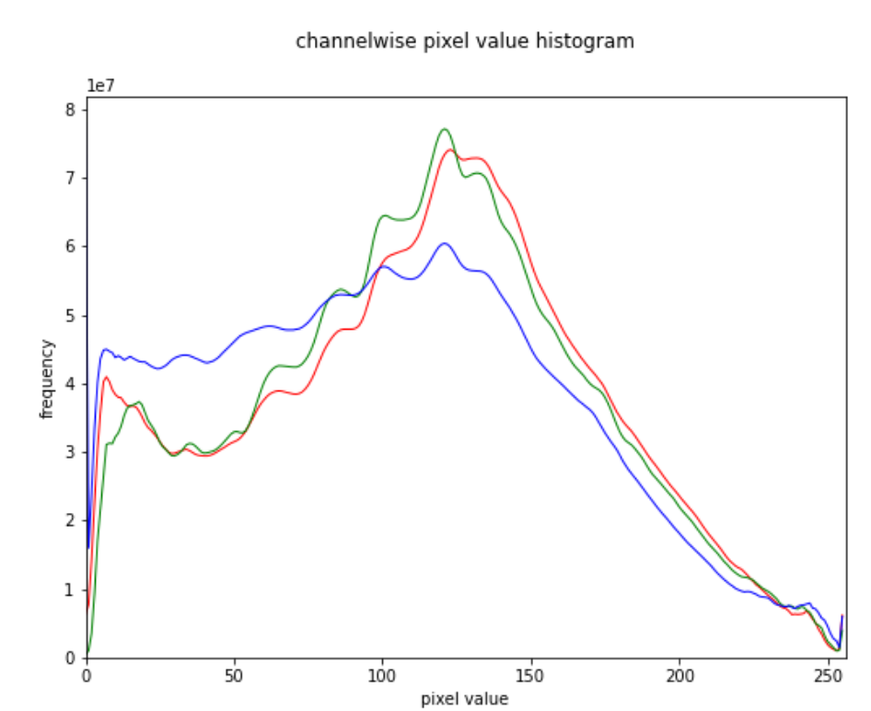
In dataset 2 there are 400 images captured from a drone that is at a height between five and thirty meters off of the ground. The original images are all the same size at 6000 x 4000 x 3. The pixels in the original dataset are in the range from 0 to 255. This drone dataset also contains a ground truth masking for each of the images. The values of the pixels in the ground truth masking range from the values of 0 to 23. A few examples of the class labels person, vegetation, tree, and bicycle. Again the blue channel has the highest standard deviation of all three of the channels.
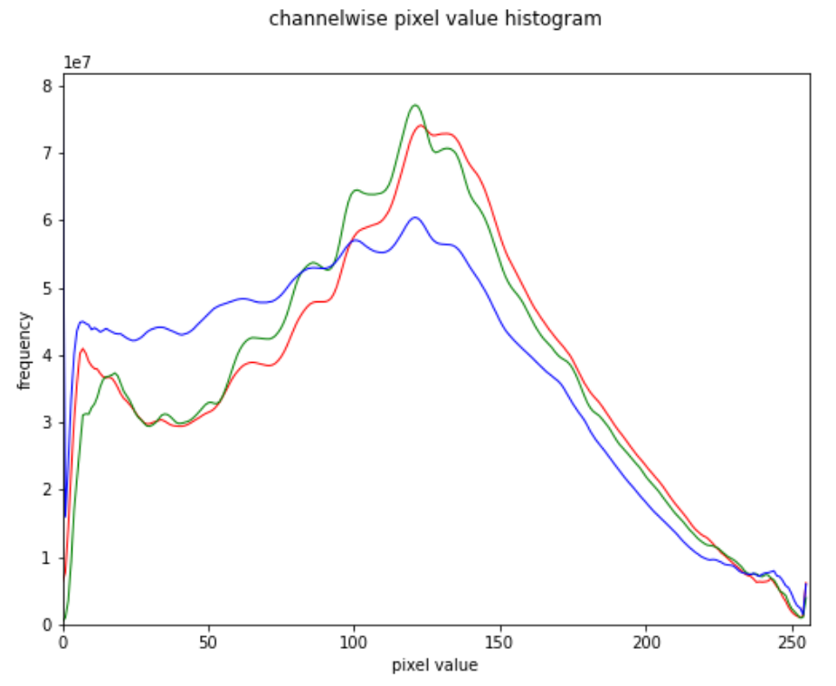

Non-graphical and graphical univariate analysis
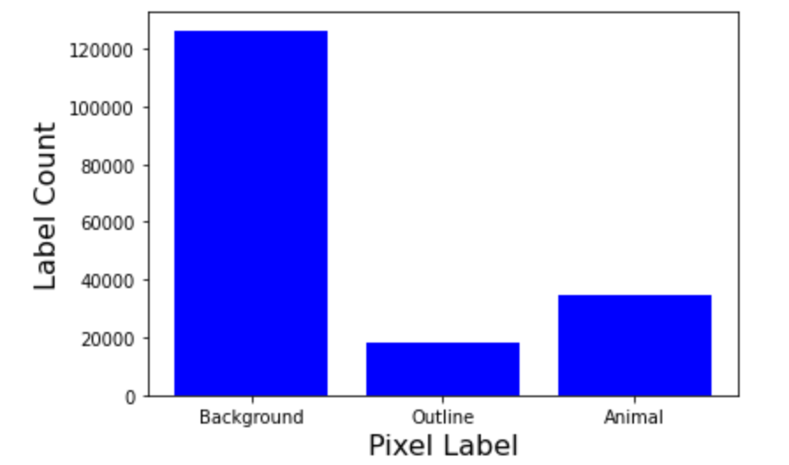
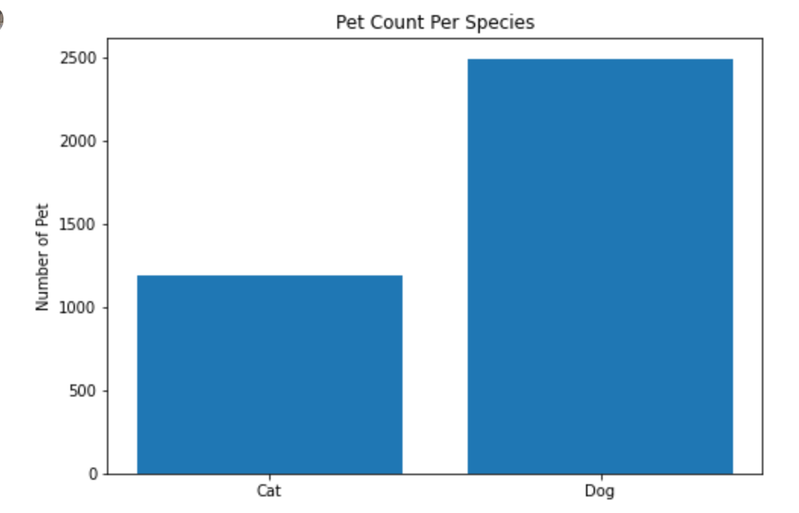
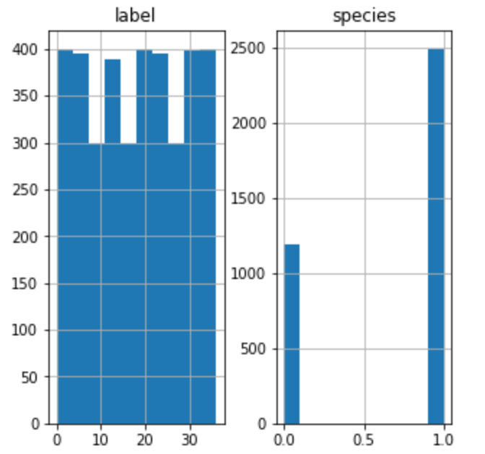
Pet Dataset:The pixel values are in the range from 0 to 255. The histogram for the class labels is shown below. We can see that the background is the majority of the class labels with over 120,000 pixels representing the background while the outline and animal combined is less than half of that.
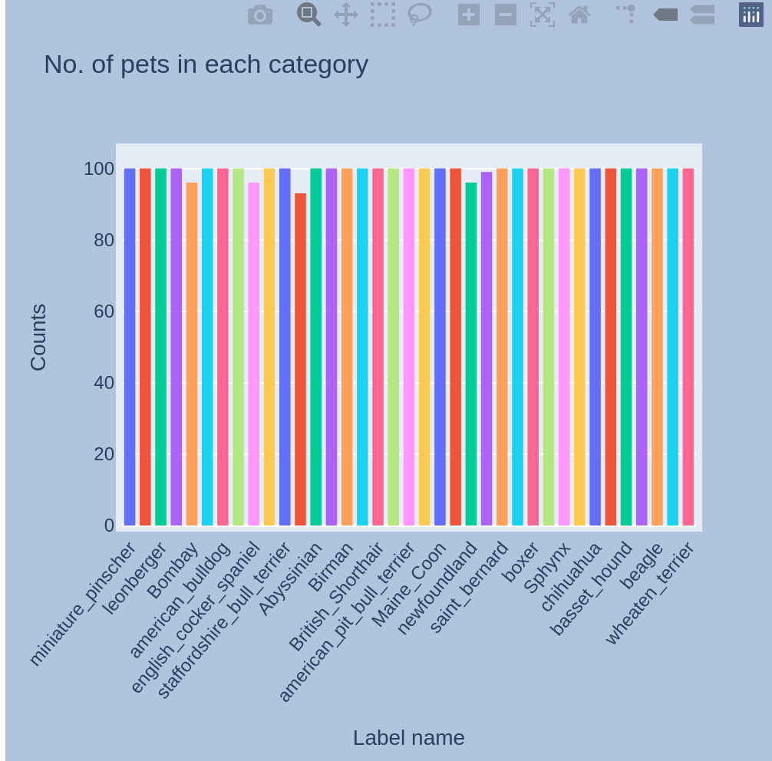
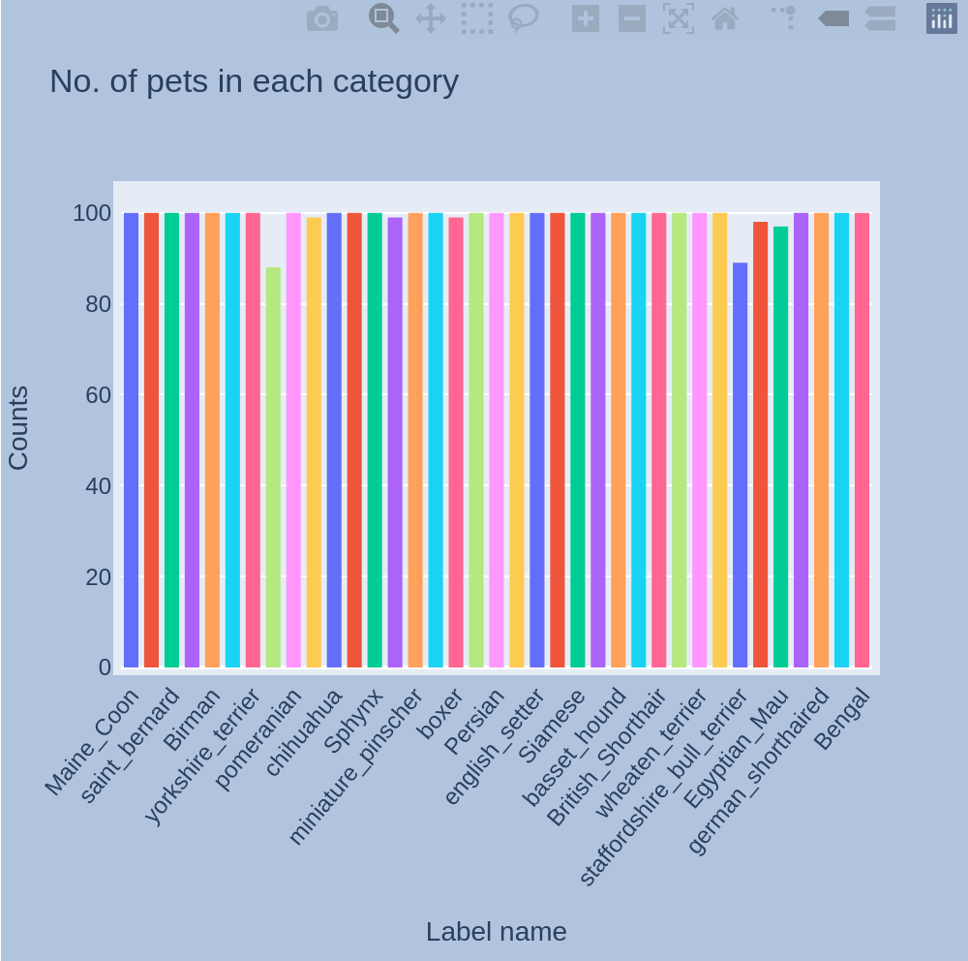

Drone Dataset:
The original images in the drone dataset have pixel values between 0 and 255. The histogram for the pixel class labels is shown below. Also below is the histogram of pictures with class labels per channel.
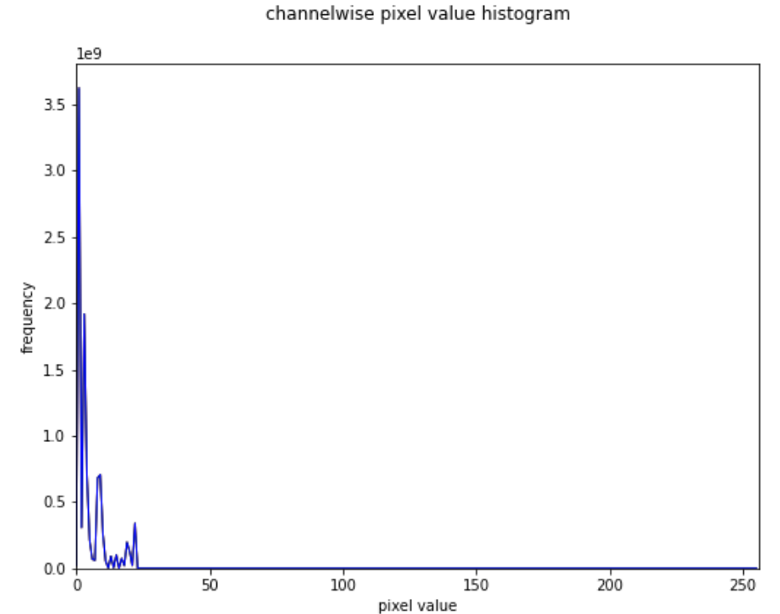
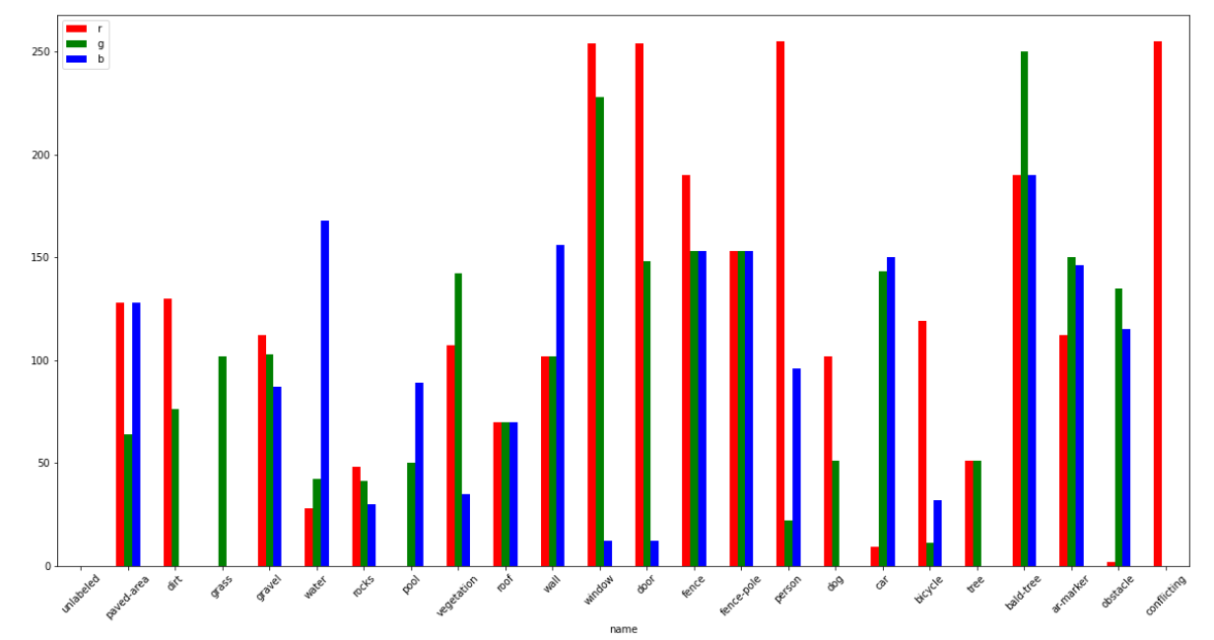

Missing value analysis and outlier analysis
Pets Dataset:
There are no missing values for any of the images in the dataset. For the pixel values there are also no outliers for this image dataset. All original images have pixels in the range from 0 to 255. The original image size varies and there are a few outliers in the size of the image. However each image when training will be resized to all the same size.

Drone Dataset:
There are no missing values for any of the images of the drone dataset. There are also no outliers in pixel value or image size with the drone dataset.

Feature engineering and analysis
Pets Dataset:
There is minimal feature engineering that needs to be done for the pets dataset. The only engineering that needs to be done is to normalize the pixel values and to resize the image when loading it from the directory. For each column the column mean is found and subtracted. The recommended resizing value of the dataset is given in the analysis of the basic metrics section.
Drone Dataset:
There is also minimal feature engineering that needs to be done for the drone dataset. The original and ground truth mask images need to be resized when loading from the directory. Also for the original images they will be normalized. The column mean for the dataset is found and subtracted.

